DO

■We need two VMs (let’s say “server” and “client”)

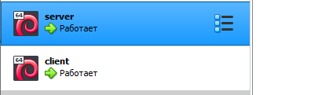

■Install NTP server on the “server” instance





■Connect our client to the server to synchronize the time from it (configure to do it once in 5 minutes)

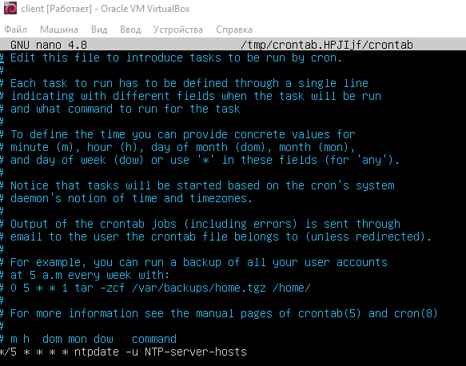

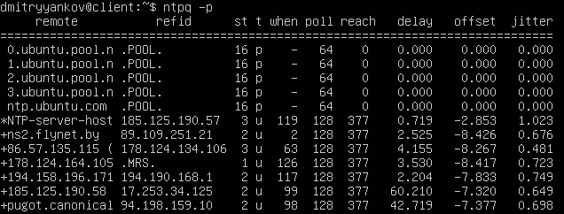

■Install Nginx web-server on the Client VM



■Add Nginx to autostart of the system

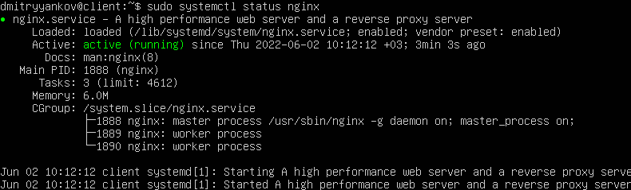

■Restart the VM and double-check that Nginx is up-and-running

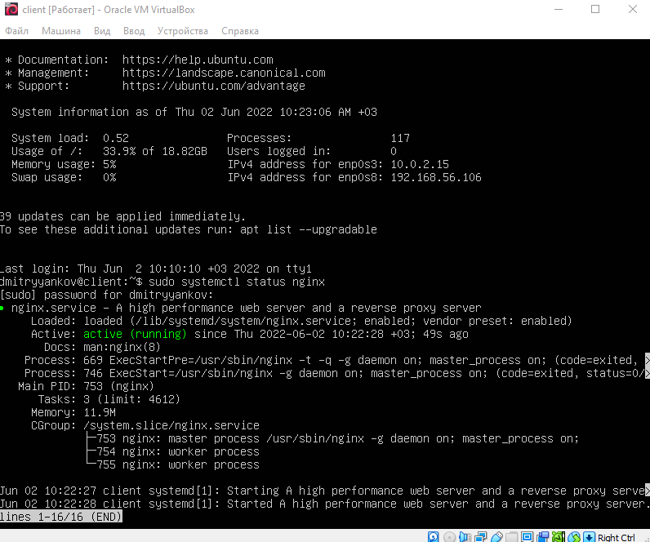

■Configure and test the SSH connection from the Client to the Server

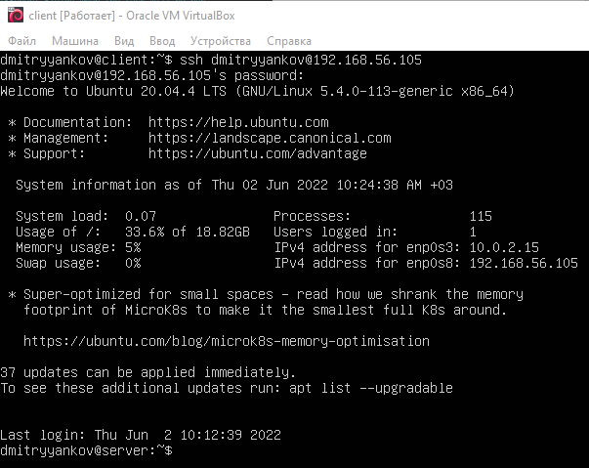

■Install two different PHP versions (7.1.x + 7.4.x)(one from apt repository and one from ppa repository). Check default PHP version after that!!!! (Additional screenshot needed)

Ставил php 7.4 этой командой

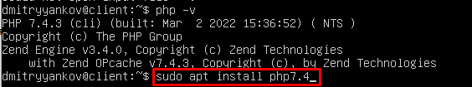

php 7.1

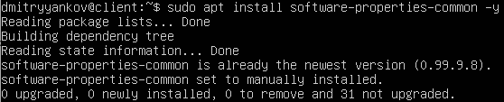

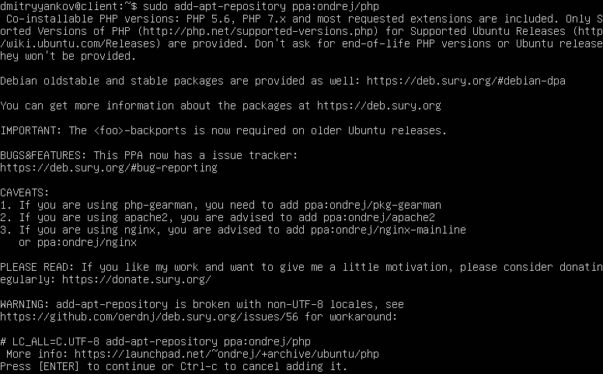

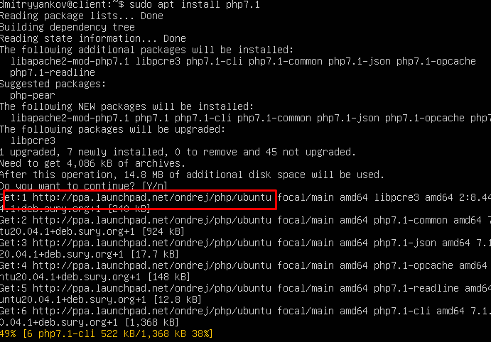

■Make both versions available for usage (using links and PATH value).

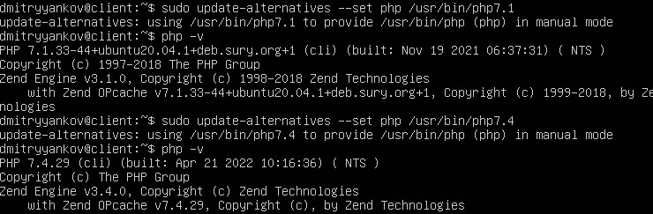

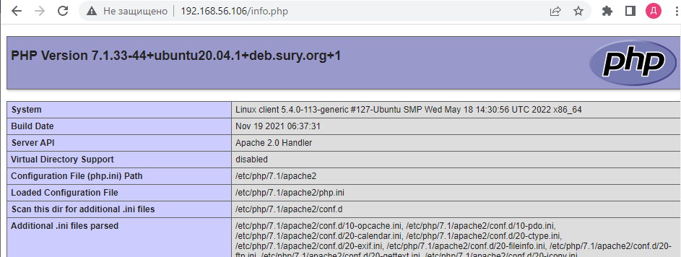

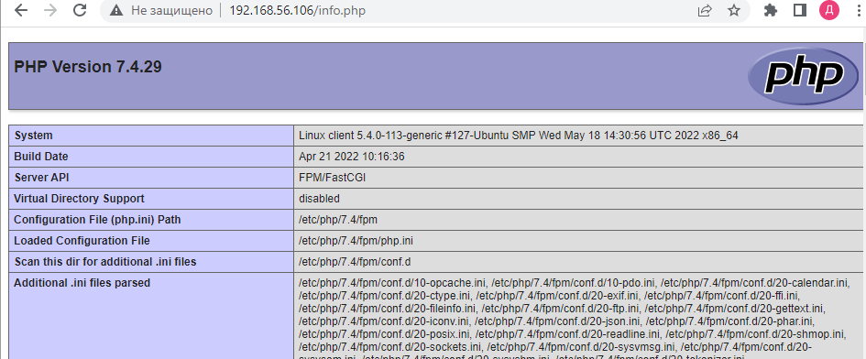

■Make it easy for use to switch between them

Send screenshots confirming the readiness of each task above